The speaker was discussing about how honey that we buy from the market is not real. They mentioned about how bees produce honey. They also discussed that the researcher found that 50% of the honey that are selling on the market is not real. Finally, they suggested that the fake honey is make of corn syrup product with a honey.

The speaker was discussing about the health care system. She mentioned that beside focusing on the symptoms, we should also pay attention on improving health where it begins. She also discussed that where health begin include where spend our majorities of our lives. Finally, she suggested that by looking at the big picture, we can manage a lot of health issue.

The speaker was discussing about the different between human and other species. He mentioned that human build all kinds of things like car, radio program while species do not invent anything; they live the forest for years. He also told how animals are so different from human. He discussed that human brain have more cortexes than other species. Finally, he suggested that these cortexes differentiate human from animal.

The speaker was discussing the cognitive history of 20th century. She mentioned about the change in our mind. And how people used to confront from the concrete world to the complex world. She discussed about how we develop new metal habit include classification and abstraction. Finally, she suggested that she received a lot of IQ test.

The speakers were discussing about the zika virus on pregnant women. They mentioned that it caught the doctors and government unprepared. They also discussed about how they develop cat methods to fight again this problem. They also mentioned that this method helps detecting the outbreak and pinpoint what they are fighting. Finally, they suggested that CAT is used generally in Africa.

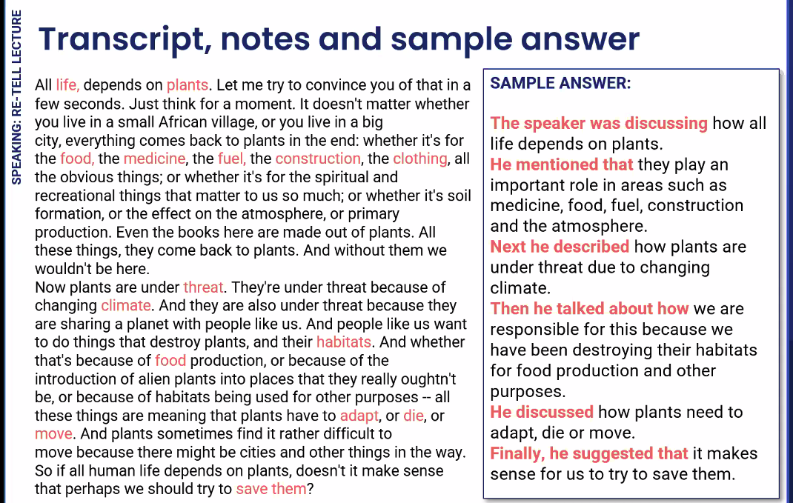

This line graph shows profits from sales of coffee, espresso, herbal tea, and tea from December 2011 through to December 2013.

Coffee was the most profitable commondity through most of the period while tea was the least profitable. Sales of all products fluctuated in a similar pattern. All experienced a sudden rise in profitability from December 2012 and this was sustained. A peak occurred after June 2013 for coffee, herbal tea and tea, but not for espresso.

In conclusion, it could be predicted that profitability of these commodities will continue to fluctate into the future.

This linge graph illustrates UN 2012 population projections in Africa and Europe from 1950 to 2100.

At the start, in 1950 , the African polulation was lower than Europe’s. but by the end of the period, in 2010, it is expected that Africa’s population will be far in excess of Europe’s. Europe’s population has remained relatively flat over the period. On the other hand Africa’s poulation has risen steadily, equalling Europe’s in 1995 and continuing a dramatic rise from that point.

A possible reason for these population changes may be cultural and finacial differences between the two regions.

This line graph shows past, current and projected population in China and India between 1990 and 2050.

At the start of the period, in 1990, Indian population was substantially lower than China’s. But by the end of the period, in 2050, it is expected to be sbstantially higher. India’s population shows a steady increase over the 60 year period while China’s population continues to rise and peaks in 2030 after which it begins to decline. It is expected to be at 2015 levels again by the year 2050.

A possible for these changes in population may be national planning policies.

The pie chart represents vaiours expenditures incurred in publishing a book.

The largest cost is paper at 25 percent of the total while the smallest costs are promotion and transport at 10 percent each. Other substantial costs are binding and printing at 20 percent each and royalty at 15 percent.

In conclusion, it could be predicted that if businesses are aiming to save money in the future, it would be useful to look at sourcing cheaper paper and perhaps looking at alternative forms of bindg.

